SRM Institute of Science and Technology, Ramapuram
21GNH101J- PHILOSOPHY OF ENGINEERING

QUESTION BANK
UNIT 1
Introduction to Philosophy of Engineering

- Engineering Habits of Mind – what are they and how can we cultivate them?
- Desired attributes of an engineers (at least 10). And tell two specific attributes of computer science engineers.
- Define:
- Engineering ii) Philosophy iii) Science iv) Art v) Mathematics
- Brief engineering developments in Renaissance ERA.
- Give the list of motivated functions of ARTS.
- How attributes of engineering help society.
- Why did STEM become STEAM.

Long answer type question
- Give the brief history of engineering development. And compare prehistory, medieval and present engineering development.
- What is the STEAM Pyramid? Describe different levels of STEAM Pyramid. Analyse STEAM Pyramid with ART context.
- Explain engineering habits of mind. and give attributes of engineers with short description.
- What are the stages of engineering history. Compare prehistory, medieval and present engineering development with real engineering examples.

MCQ
UNIT 1
Introduction to Philosophy of Engineering

- Philosophy is originally a word
A. ENGLISH
B. LATIN
C. GREEK
D. SPANISH

- Philosophy deals with of reality
A. a part
B. the whole
C. the illusion
D. none of these

- Metaphysics is a branch of
A. physics
B. metaethics
C. philosophy
D. none of these

- Science is not based on
A. experiment
B. faith
C. observation
D. hypotheses
- Philosophy is concerned with
A. The irrational
B. The ideal
C. The Positive science
D. The Descriptive science

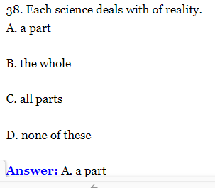
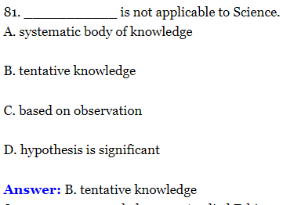
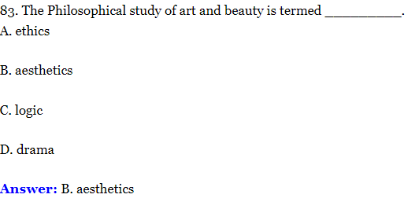

- What is the individual level factor that can affect the process of decision making in an organization?
A. Personal values
B. Economic conditions
C. Organizational Politics
D. Organizational Policies

- Select the inappropriate statement about Teamwork
A. More challenging problems can be tackled faster by drawing on
the team’s collective skills
B. No one can complete a project/task on their own, they need team members contribute and cooperation
C. Teamwork drives to un-successful and dropping of work
D. Courtesy and tact goes a long way in building team trust

- The four main divisions of philosophy are metaphysics, epistemology, axiology, and _____.
A. Bioethics
B. Logic
C. Aesthetics
D. Categorical logic

- ___________were defined to include “essential skills for citizens in the 21st century” including creativity, systems thinking, collaboration, communication and attention to ethical considerations.
A. Engineering habits of mind
B. Learning habits of mind
C. System Thinking
D. Philosophy of engineering

- STEAM stands for
A. Science, Technology, Engineering, Arts and Maths
B. Science, Technology, Engineering, Arts and Management
C. Science, Trigonometry, Engineering, Arts and Maths
D. Science, Technology, Engineering, Algebra and Maths

- Mathematics is related to
A. Technical proficiency
B. Emotional power
C. Elemental practices of counting and measuring
D. Understanding physical world

Which is not a part of STEAM?
A. Science
B. Technology
C. Engineering
D. Education
- Which is not the main category used by the ITEA to define technological literacy
A. Understanding the Nature of Technology.
B. Understanding of Technology and Society.
C. Understanding of Design.
D. Understanding of Art.
- Among the following invention which is not belong to Modern Era?
A. Wheel
B. Aerospace technology
C. Pesticides
D. Robotics

